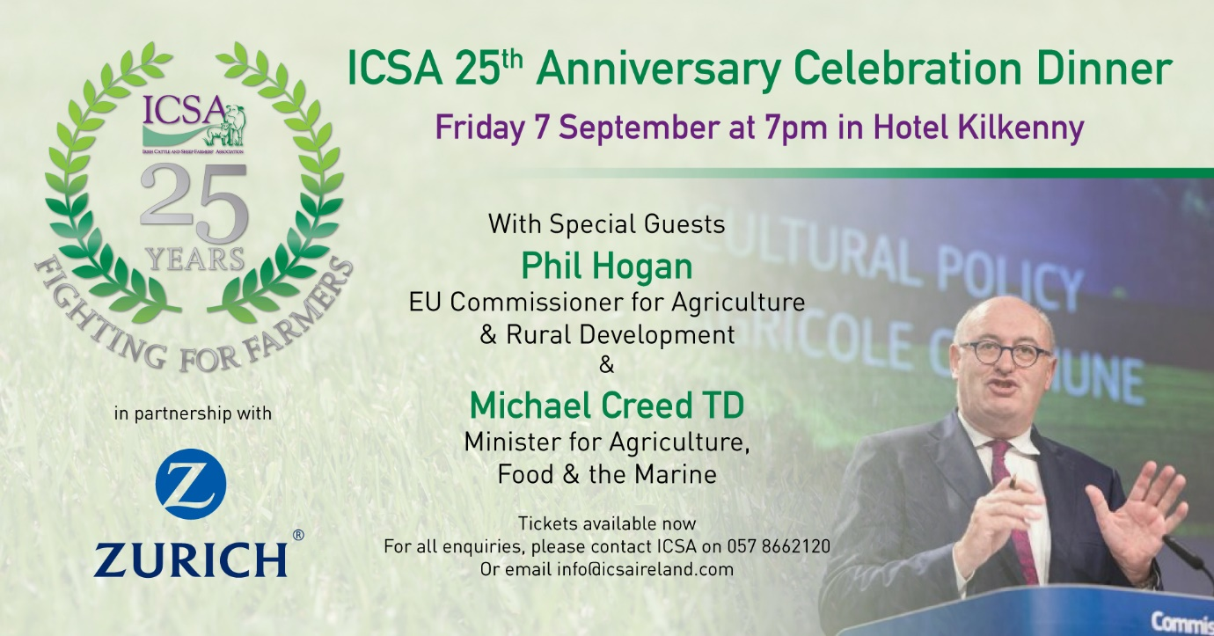

ICSA is hosting its 25th anniversary gala dinner at Hotel Kilkenny on September 7th.
Special guests and keynote speakers will include the EU Agriculture Commissioner Phil Hogan and Minister for Agriculture Michael Creed TD.
Pre-dinner, we will host ‘Small Talk - Big Issues’ conversation circles to discuss solutions to the most intractable problems facing Irish farming and rural society. This will be followed by reception drinks and a four course meal with wine.
After dinner there will be a sports panel discussion, facilitated by RTE’s Marty Morrissey, featuring three nationally known GAA and rugby superstars with a farming background.
Music on the night by The Irish Rovers

Running Order
Pre-dinner ‘Small Talk - Big Issues’: 6pm
Drinks reception: 7pm
Dinner: 8pm
Guest speakers: 9pm
Sports panel: 10pm
Music: 11pm

Message from Phil Hogan
EU Commissioner for Agriculture & Rural Development
“I am delighted to have the opportunity to be associated with the 25th anniversary of the Irish Cattle and Sheep Farmers' Association. It is indeed coincidental that, at a time when the Commission has proposed significant changes to the Common Agricultural Policy, ICSA should have emerged as a farming lobby group following the MacSharry Reforms in 1992.
ICSA has proven to be an effective and articulate voice on behalf of the farmers it represents over that quarter of a century. Over the last nearly four years, ICSA has always engaged with me, my cabinet and the services of DG AGRI on a constructive and positive basis and I look forward to our continued engagement over the next year or so, when there is still so much to be done to support farmers in the areas of CAP reform, UTPs etc.
Having published our proposals for the future of the CAP, I hope that we can start the negotiations shortly. It is important that ICSA's voice is heard so that we can deliver a reform to the policy that delivers genuine simplification for farmers and facilitates the modernisation and improved competitiveness of agricultural production.
In conclusion, I would like to reiterate my congratulations on reaching this important milestone and I wish ICSA every success for the next 25 years”
Phil Hogan
For ticket enquiries, please contact ICSA on 057 8662120 or email info@icsaireland.com

